APPLICATION FOR ASSOCIATE MEMBERSHIP

Name of Regional Government: ________________________

The regional government written above agrees on the founding spirit of the Association of North East Asia Regional Governments (NEAR) and applies for the associate membership of NEAR.

Date:

Signature of President/Governor/Mayor: __________________

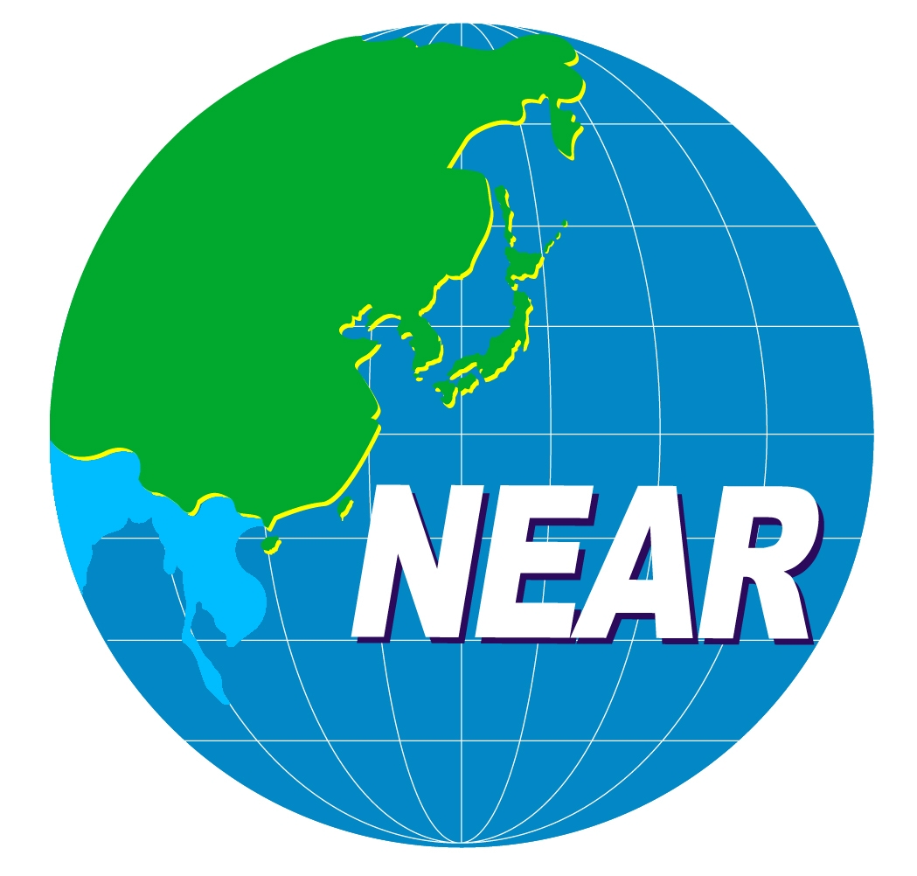

The Secretariat of the Association of

North East Asia Regional Governments

